Database Transaction in Lesson Notes Distribution

An Assignment submitted in partial fulfillment of the requirements for the degree of
Bachelor of Science
in
Computer Science

CS 3306: Databases 2

Term 4 - 2025
University of The People

Instructor: Dr. Afrah Nazir

May 21st 2026

Database Transaction in Lesson Notes Distribution
In this week’s learning activities, I observed that database systems support many routine tasks in education by organizing files, controlling access, and keeping records of user actions. I am a teacher, and part of my mandate is to share lesson notes with students via the Google Classroom platform, which I would consider an example of transaction flow that I have engaged with this month. Figure 1 illustrates this transaction flow, where the teacher uploads learning materials, Google Classroom manages the process, Google Drive stores the files, and a notification service alerts students when new content becomes available. According to Silberschatz, Korth, and Sudarshan (2001), transactional workflows extend traditional transaction concepts to coordinated, multi-step activities that require correctness, integrity, and durability across the entire process. My example shows how a database-backed system supports a complete transaction from upload to student access while maintaining consistency and availability of data.
The transaction begins when I prepare lesson notes such as PDF files, slides, videos, or assignment instructions and upload them to Google Classroom for my students. Although Google Classroom serves as the visible learning management system, the actual stored data is kept in Google Drive, which functions as the underlying repository for the uploaded files. In this case, the database stores file information, storage links, access permissions, class associations, and timestamps that allow the system to retrieve the materials correctly for authorized students. From my perspective as a teacher, I do not interact directly with the database itself, but I rely on it whenever I post materials and make them available to my class.
As shown in Figure 1, once I complete the upload, Google Classroom passes the files to Google Drive for storage and then triggers the notification service. The notification service sends an alert by email or through the application so that students know that new learning materials have been posted. After receiving the alert, students log in to Google Classroom, open the announcement or post, and then view or download the materials linked from Google Drive. This sequence demonstrates an organized transaction because each step depends on the successful completion of the previous one, ensuring that the right files are available to the right users at the right time.
Reflecting on this example helped me understand that databases are not limited to banks or business systems; they are also essential in everyday academic activities. In my role as a teacher, the distribution of lesson notes depends on accurate storage, secure access control, and timely retrieval of information so that teaching and learning can continue smoothly. It also demonstrates important database concepts such as consistency, reliability, and controlled data sharing across multiple users. In a nutshell, this was a practical transaction that I personally carried out, and it clearly shows how database systems operate behind the scenes in modern digital learning environments.
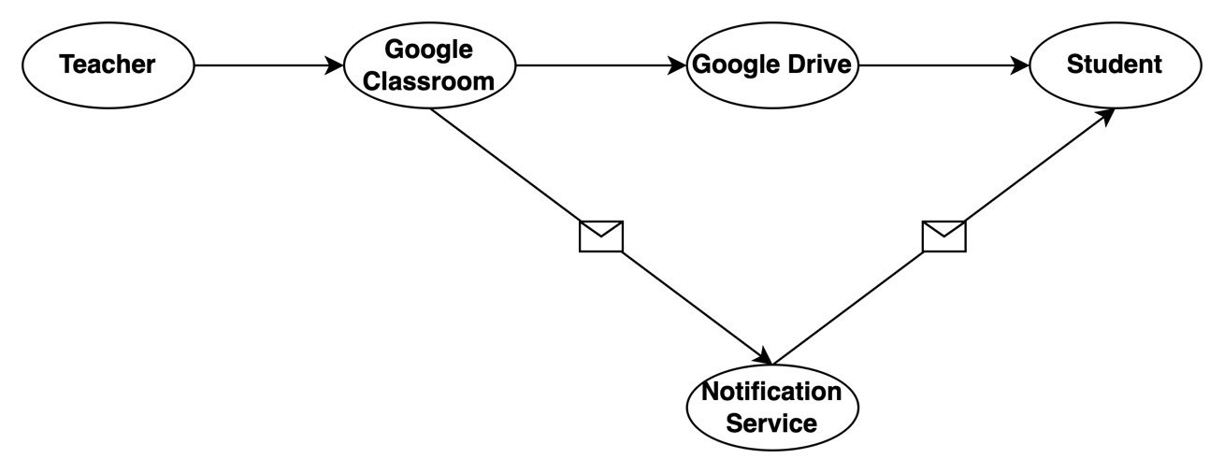
Figure 1: Lesson notes submission transaction flow

Reference
Silberschatz, A., Korth, H.F., & Sudarshan, S. (2001). Database system concepts (4th ed.). New York, NY: McGraw-Hill.

